**National University of Computer and Emerging Sciences**



**Lab Manual 05**

**AL2002-Artificial Intelligence Lab**

|  |  |
| --- | --- |
| Course Instructor | Dr. Hajra Waheed |
| Lab Instructor (s) | Muhammad Ahmed  Hamza Ayub |
| Section | B1 – B2 |
| Semester | Spring 2023 |

Department of Computer Science FAST-NU, Lahore, Pakistan

Table of Contents

1. Objectives 3
2. Task Distribution 3
3. Genetic Algorithm 3
   1. History 3
   2. What is Genetic Algorithm (GA)? 3
   3. Genetic Algorithm Flow 4
   4. Population 4
   5. Fitness and Selection 4
   6. Mating / Crossover / Generating Genrations 5
   7. Mutation 5
4. Problem Solving using Genetic Algorithm 6
5. Exercises 9
   1. Exercise 1: 9
   2. Exercise 2: 9
6. Submission Instructions 9

# Objectives

After performing this lab, students shall be able to understand the following Python concepts and applications:

* + Genetic Algorithm
  + Solving Problem using Genetic Algorithm

# Task Distribution

|  |  |
| --- | --- |
| **Total Time** | **170 Minutes** |
| Genetic Algorithm Introduction | 25 Minutes |
| Application of Genetic Algorithm | 25 Minutes |
| Exercise | 120 Minutes |
| Online Submission | 10 Minutes |

1. Genetic Algorithm

## History

* + - As early as 1962, John Holland's work on adaptive systems laid the foundation for later developments.
    - By the 1975, the publication of the book Adaptation in Natural and Artificial Systems, by Holland and his students and colleagues.
    - early to mid-1980s, genetic algorithms were being applied to a broad range of subjects.
    - In 1992 John Koza has used genetic algorithm to evolve programs to perform certain tasks. He called his method "genetic programming" (GP).
    - A genetic algorithm (or GA) is a search technique used in computing to find true or approximate solutions to optimization and search problems.
    - (GA)s are categorized as global search heuristics.
    - (GA)s are a particular class of evolutionary algorithms that use techniques inspired by evolutionary biology such as inheritance, mutation, selection, and crossover (also called recombination).

## What is Genetic Algorithm (GA)?

* + - The evolution usually starts from a population of randomly generated individuals and happens in generations.
    - In each generation, the fitness of every individual in the population is evaluated, multiple individuals are selected from the current population (based on their fitness), and modified to form a new population.
    - The new population is used in the next iteration of the algorithm.
    - The algorithm terminates when either a maximum number of generations has been produced, or a satisfactory fitness level has been reached for the population.

## Genetic Algorithm Flow

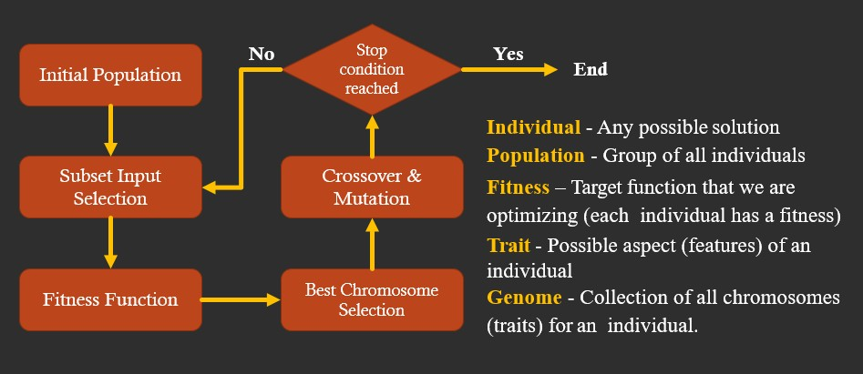

## Population



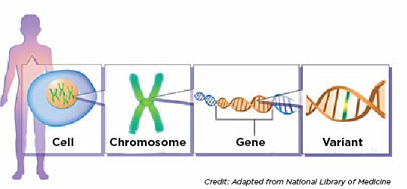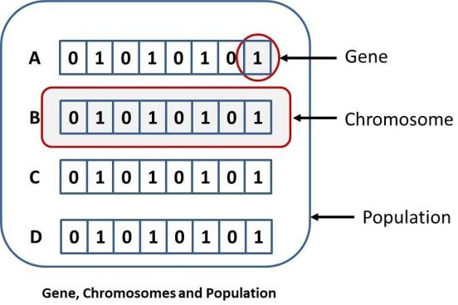

## Fitness and Selection

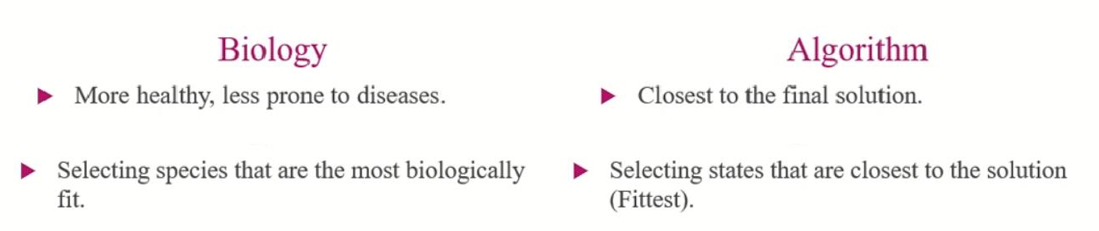

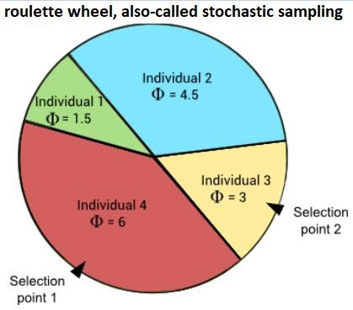

## Natural SelectionMating / Crossover / Generating Genrations

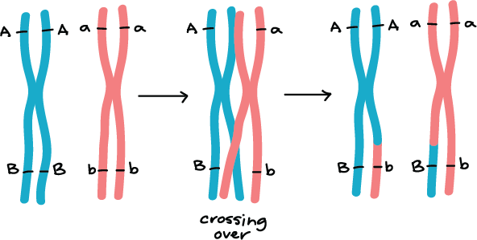 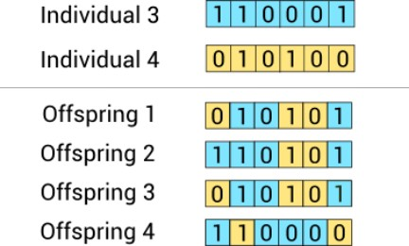

## Mutation

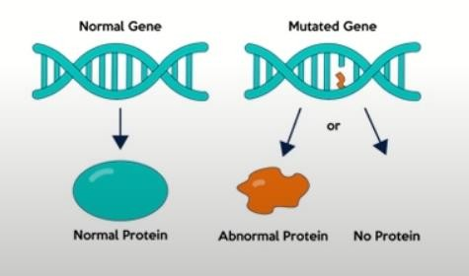 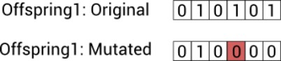

1. **Problem Solving using Genetic Algorithm**

Famous Problems using Genetic Algorithms:

### KnapSack Problem

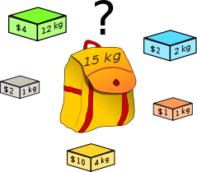

### 8 Queen Problem

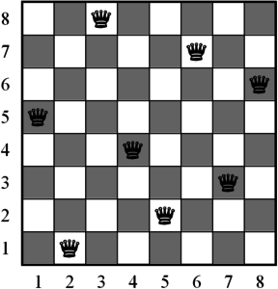

### Optimization Problems/ Finding Global Maxima of a Function

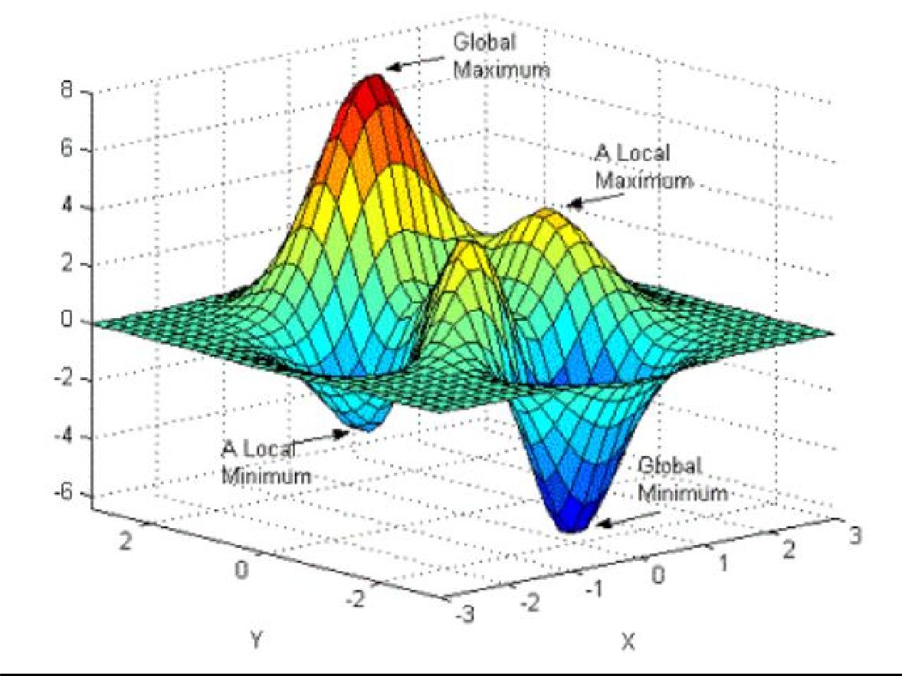

Let’s try to find optimized solution of a function:

Let’s have random expression which evaluates to 25:

6𝑥3 + 9𝑦2 + 90𝑧1 = 25

Problem: What could be the best possible values of x, y and z that could satisfy the above expression.

For this purpose, we make function in python such that:

def evaluateExpression(x, y, z):

return 6 * x ** 3 + 9 * y ** 2 + 90 * z - 25

This function that evaluates the expression to 0 if the answer of expression " 6 * x ** 3 + 9 * y ** 2 + 90 * z " is 25. So That's mean we need the most suitable values of x, y and z so that we could achieve our target value which is 25 in this case.

Now we need to apply Genetic Algorithms concepts to solve this problem. Step1: Population of Solutions.

Population is generated entirely from random numbers let say up to 1000 individuals.

# generate solutions population import random

solutions = []

for counter in range(1000):

solutions.append((random.uniform(0, 1000), random.uniform(0, 1000), rand

om.uniform(0, 1000)))

Step2: Fitness function: So the fittest solution will be the one, which evaluates the expression to "0". Otherwise, the best solution will be closest to zero. Therefore, the fitness in this case is the highest if the solution is closest to zero. Hence, we can return highest fitness value to those solutions, which are closest to 0.

def fitness(x, y, z):

ans = evaluateExpression(x, y, z)

if ans == 0: return 99999

else:

return abs(1 / ans)

Step3: Mating, Crossover or Generating the Generations:

During each generations, further sub steps performed such as:

Step 3.1: Selection of top ranked solutions

Step 3.2: Mutation or slight changes or variation in values of solution.

P.S. Here for the sake of analogy if solution can be considered as chromosome then variable values can be considered as genes)

for generation_count in range(10000): rankedSolutions = []

# fitness step

for solution in solutions:

rankedSolutions.append((fitness(solution[0], solution[1], solution[2])

, solution)) rankedSolutions.sort() rankedSolutions.reverse()

print(f"=== Generation {generation_count} best solutions ====") print(rankedSolutions[0])

if rankedSolutions[0][0] > 999: break

bestSolution = rankedSolutions[:100] # print(bestSolution)

# selection step

variables = []

for solution in bestSolution: variables.append(solution[1][0]) # variable x variables.append(solution[1][1]) # variable y variables.append(solution[1][2]) # variable z

newGeneration = [] # mutation step

for counter in range(1000):

x = random.choice(variables) * random.uniform(0.99, 1.01) y = random.choice(variables) * random.uniform(0.99, 1.01) z = random.choice(variables) * random.uniform(0.99, 1.01)

newGeneration.append((x, y, z)) solutions = newGeneration

Note: After running this code given in Jupyter Notebook, confirm the values from best optimized

solution into given expression to verify

1. **Exercises**

## Exercise 1:

Run the given code and verify the solution. Change given expression to any other expression of your choice; change the parameters to increase the efficiency of code if possible.

## Exercise 2:

Implement 8-queen problem using genetic algorithm.

For help regarding representation of states you may watch the following video: <https://www.youtube.com/watch?v=vXotl0NPeUU>

1. **Submission Instructions**

Always read the submission instructions carefully.

* Rename your Jupyter notebook to your roll number and download the notebook as **.ipynb**

extension.

* To download the required file, go to **File->Download .ipynb**
* Only submit the **.ipynb** file. DO NOT **zip** or **rar** your submission file.
* Submit this file on Google Classroom under the relevant assignment.
* Late submissions will not be accepted.